Scheduling
Contents:
Phoenix Summary ………………………………………………………………………………………….. Page 2
Needs Review by CCC …………………………………………………………………………………….. Page 9
NWP Cover Sheets …………………………………………………………………………………………. Page 10
MFM Scheduling Rules ………………………………………………………………………………….. Page 14
Genetic Scheduling ………………………………………………………………………………………… Page 17
Mod Risk Scheduling …………………………………………………………………………………….. Page 19
Term of Care Workflow …………………………………………………………………………………. Page 20
Prior Authorization Workflow ………………………………………………………………………… Page 21
Checking OHP for New Patients ……………………………………………………………………… Page 22
Pediatric Urologist Scheduling ………………………………………………………………………… Page 25
Pediatric Cardiology Scheduling ……………………………………………………………………… Page 26
Dating/Viability and SEQ Orders ……………………………………………………………………. Page 30
NWP Appointment Note Standard ………………………………………………………………….. Page 31
Behaviorist Scheduling …………………………………………………………………………………… Page 32
HIPAA Scripting ……………………………………………………………………………………………. Page 36
28wk Lab (GTT) or Early GTT Workflow …………………………………………………………. Page 38
PMHNP Scheduling ………………………………………………………………………………………. Page 39
PMHNP No Show Policy effective 2/13/2017 …………………………………………………… Page 43
Surrogacy Pregnancy Scheduling …………………………………………………………………… Page 46
Postpartum 3 week scheduling ………………………………………………………………………. Page 47

Phoenix Summary:
To be done for: Initial MFM and Mod Risk Consults, Genetic Consults, and OB Ultrasounds (not needed for GYN ultrasounds).
You will get a referral/order from provider’s office. If the provider is external (i.e. a Providence Provider) you will usually be provided with a faxed referral. Providence referrals do not come with much information, so you will need to contact the referring office to get additional demographics for the patient in order to be able to contact her for scheduling.
If the referring provider is a WHA provider, there will be an order placed within Centricity. The Clinical Care Coordinator will create the Phoenix Summary from these orders and then route to the Scheduling Proxy as needed.
Notes: __________________________________________________________________________________________________________________________________________________________________________________________________________________________________________________________________________________________________________________________________________________________________________________________

To launch a new Phoenix Summary:
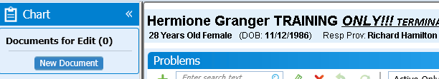
From your patient’s chart click on “New Document”

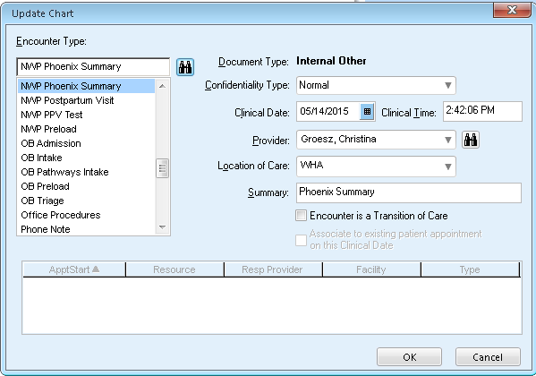
Choose “NWP Phoenix Summary” and then click “OK”

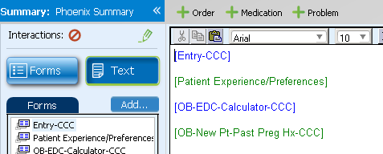
Click on the “Forms” tab or Entry -CCC

Launching a Phoenix Summary (Continued)

Under “Entry - Page 1” the following should be completed:
- LMP
- EDC
- Ordering Provider and Order on Chart
- Location
- If preferred language is other than English and if applicable, if an interpreter is needed

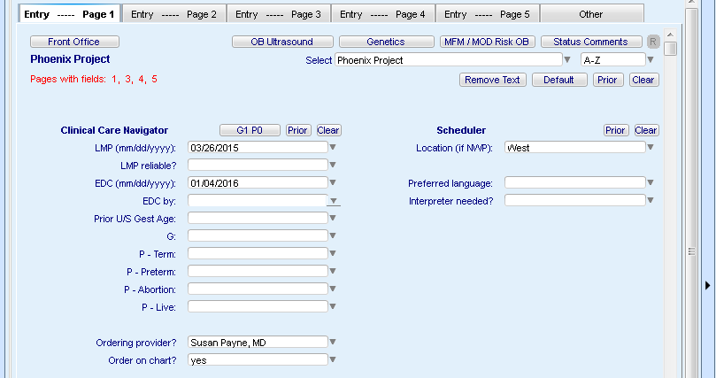

Launching a Phoenix Summary (Continued)

Skip to “Entry – Page 3” OB Ultrasound
If you have been provided the information, choose the appropriate boxes under the following fields:
- Fetus
- Indication
- Any of the corresponding studies boxes.
If this information is not provided, you can leave blank.

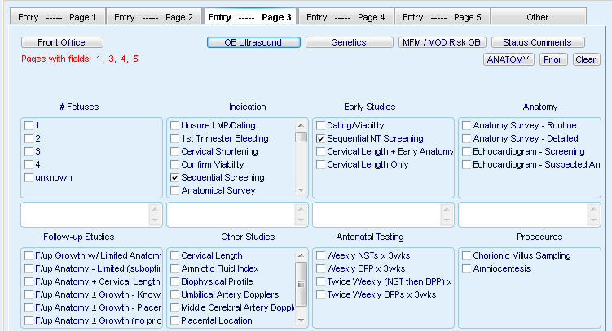

Launching a Phoenix Summary (Continued)

“Entry – Page 4” Genetics. If you have any information related to the reason for Consult, you can enter it into the appropriate fields.

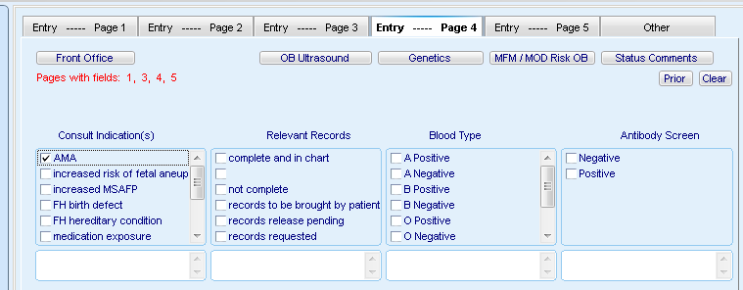
“Entry – Page 5” MFM. If referral is for MFM Consult, leave fields blank.

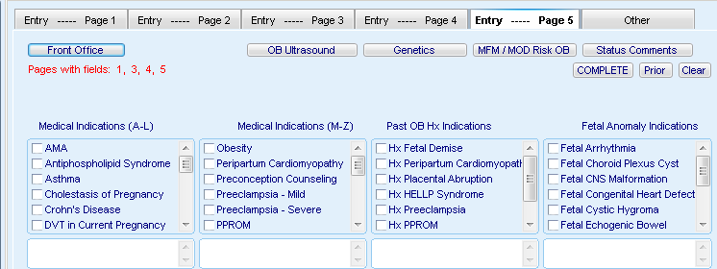

Launching a Phoenix Summary (Continued)
“Other” Status Comments. Enter a note that you have received the order.
Ex: NP (if a new patient, CP if a current patient, PP if Prior Patient), Received/ (if records too list here) order for
- Dating/Viability (if multiple orders list them out)
- SEQ 1 non AMA
After you have attempted to reach the patient, enter notes relating to that interaction.
Ex: Left message or Patient to call back to schedule

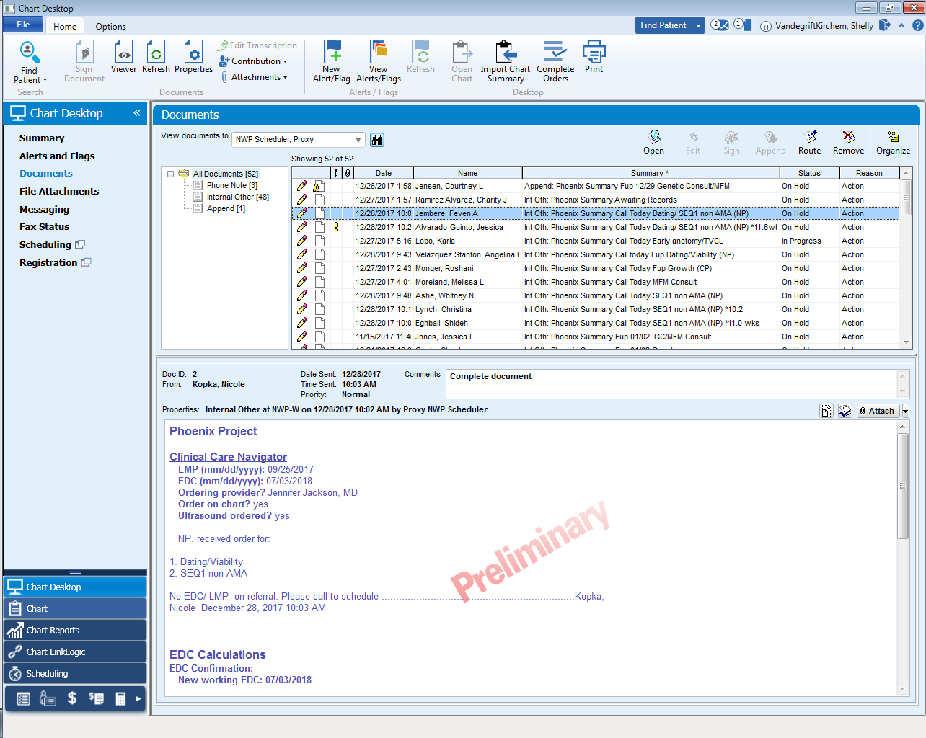

Once you have reached the patient and made an appointment, enter the appointment information.
This will include the schedule(s) you are placing the patient on, the time of each appointment, why the patient is being seen, and the Referring Provider
Ex: Appt 05/20/2015 US (315)), Lab (415), SEQ, Payne//CMG

Launching a Phoenix Summary (Continued)
End your note.
For the Summary Line: Phoenix Summary, Type of appointment scheduled, and date (MM/DD/YYYY) scheduled.
Route to the NWP CCC, Proxy

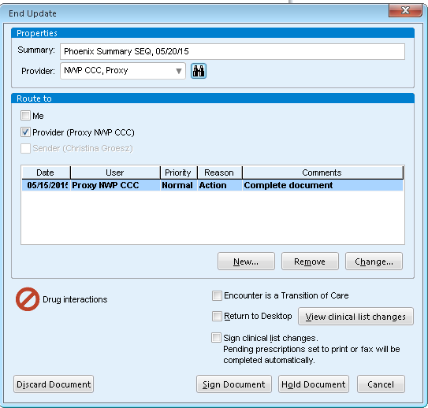

Needs Review by CCC

- MFM Consults
- Genetic Consults (for indications other than AMA)
- Detailed US- Anomalies
- Fetal Echo’s
- Fup Growth (External referrals)
- Fup Anatomy/Growth- Placenta Reasons
- Dr. Lashley
- Peds Cardiology

Notes: __________________________________________________________________________________________________________________________________________________________________________________________________________________________________________________________________________________________________________________________________________________________________________________________

MFM Roles – Scheduling Rules
General

NWP Cover Sheets
You will then need to print a cover sheet for the Referral and Records
To print a cover sheet:

From the patient’s chart, click on Print

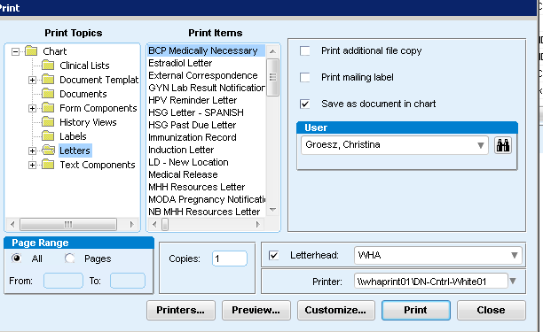
Click on Letters

Cover Sheets (Continued)
You have multiple cover sheets to choose from:

- Print the cover sheet titled: NWP Document Cover Sheet – Provider Referral and place on top of the referral so it can be scanned into the patient’s EMR when you have a referral.
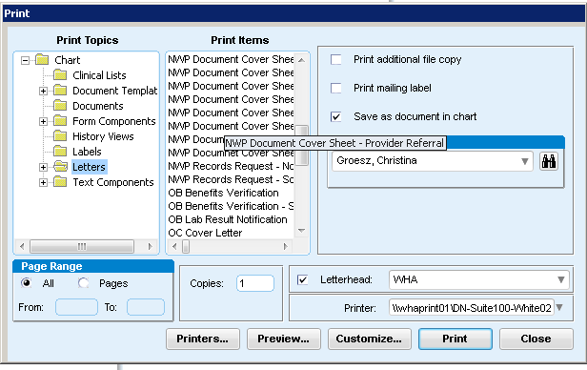

- Print the cover sheet titled: NWP Document Cover Sheet – Referring Provider Records and place on top of the patient’s records so it can be scanned into the patient’s EMR when you have records.
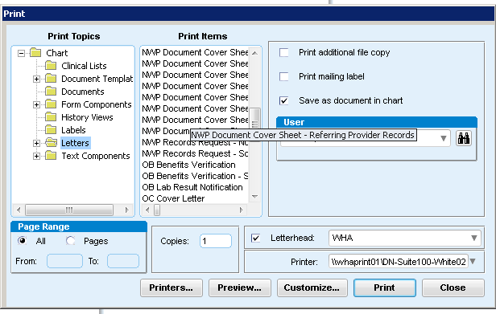

Cover Sheets (Continued)

- Print the cover sheet titled: NWP Document Cover Sheet – Records Request – Not Scheduled when you are requesting records from the referring provider’s office and are waiting to schedule until they are received and need to be reviewed by the CCC.

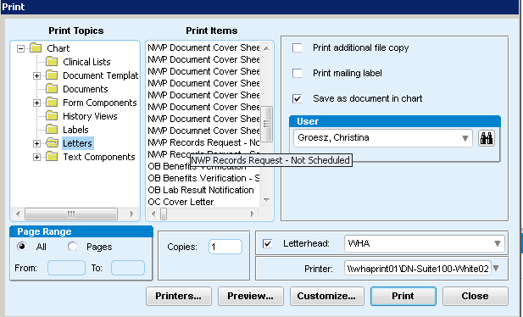

- Print the cover sheet titled: NWP Document Cover Sheet – Records Request – Scheduled when you are requesting records from the referring provider’s office, yet have already scheduled the patient’s appointment.
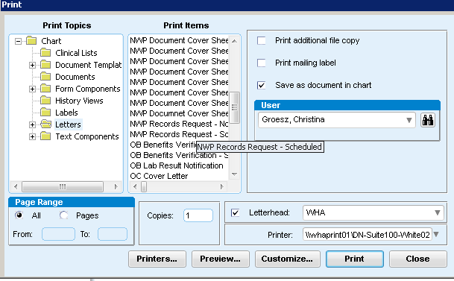
Once you’ve chosen the appropriate cover sheet, click “Customize”

Cover Sheets (Continued)

- For all types of Cover Sheets enter the following information:

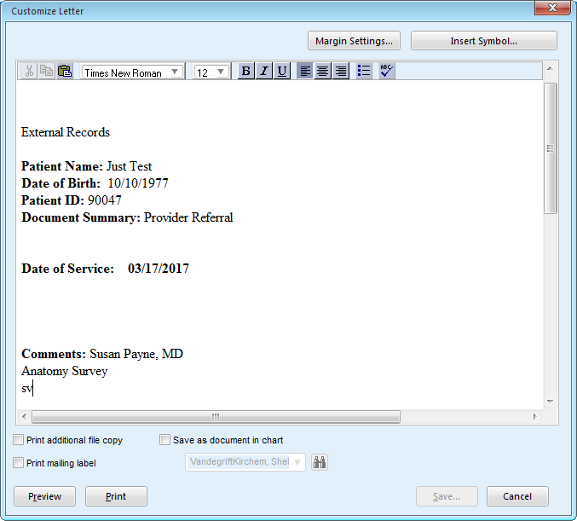
Date of Service:
Referrals: Date you received the order
Records: Most current date on records
Comments: Change to name of provider you have records from.
Below comments line add: Type of Appt and initials
Print
Attach to the referral and records (if you have them).
If you have not scheduled the patient, this will be filed away to be pulled at a later date once appointment is scheduled.
- Do not modify anything above the Date of Service line.
Notes: _______________________________________________________________________________________________________________________________________________________________________________________________________________________________________________________________________________________________________________________________________________________________________________________________________________________________________________________________________________________________________________________________________________________________________________________

MFM Roles – Scheduling Rules
General
1. Any change to a provider’s schedule within 24 hours will prompt a notification of the provider via either:
a. person-to-person communication, or
b. text message to provider’s work cell phone if provider unavailable including:
i. notification of type of adjustment (e.g. consult added, patient moved)
ii. general clinical diagnosis (e.g. new diabetic patient, ultrasound abnormality)
iii. date & time of patient to provider
iv. no patient names or identifying information should be sent via text message
Office MD
c. Can be scheduled as the current template allows with no more than 4 consults in a day split between morning and afternoon (i.e. not 3 in a row) – unless prior approval received by provider on an individual case-by-case basis.
NWP East (2 MFMs)
1. US/L&D - East MD
a. Covers L&D in the morning and is blocked from 8:00 - 9:30 AM. Office - East MD to cover early scans if unexpected finding arises or asks US/L&D - East MD to return if feasible.
b. Will not be blocked for L&D coverage in the afternoon.
c. Can have 1 routine (25 min) visits scheduled 2:35pm. There are 2 additional routine (25min) visits at 10:45am and 1:40pm listed as OB check/Clinical Disruption that you will need prior approval from the provider. You can put an FYI to GC as early at 9:20. No consults to be scheduled on the US/L&D - East MD schedule without prior approval from provider.
2. Office - East MD schedule will be per routine Office MD template and general rules.
NWP East (1 MFM)
1. US/L&D - East MD
a. Covers L&D in the morning and is blocked from 8:00 – 9:30 AM. Provider may be paged if urgent ultrasound finding, however only routine ultrasounds to be scheduled in first morning US slots.
b. Will be blocked for L&D coverage in the afternoon from 4:00 - 5:00 PM.
c. Can have 1 routine (25 min) visits scheduled 2:35pm. There are 2 additional routine (25min) visits at 10:45am and 1:40pm listed as OB check/Clinical Disruption that you will need prior approval from the provider. You can put an FYI to GC as early at 9:20.
d. No additional visits to be scheduled on the US/L&D - East MD schedule without prior approval from provider.
NWP West
1. US - West MD
a. No patient visits scheduled without approval of provider.
2. Office - West MD / Office 2 - West MD / Office 3 - West MD
a. Schedule will be per routine Office MD template and general rules.
3. L&D - West MD
a. No patient visits scheduled without approval of provider.
b. Will take on primary responsibility for referring provider calls when down from L&D if otherwise not attending to L&D duties.
c. Concept of “Protected time” to be discussed in the future for Admin/Project work (TBD).

Notes: _______________________________________________________________________________________________________________________________________________________________________________________________________________________________________________________________________________________________________________________________________________________________________________________________________________________________________________________________________________________________________________________________________________________________________________________

Background on NWP Scheduling Guidelines

Objectives:
- Provide adequate staffing for both west and east side offices
- Maintain office day continuity to provide consistency for providers and patients
- Allow east side providers with continued exposure to “higher acuity” ultrasound and L&D at west side office
- Maintain continued collegial interaction among all providers and staff
- Provide adequate coverage to allow for vacations without substantially limiting patient access or overloading individual provider schedules
Scheduling Priorities:
- Continuity of office days is a priority
- Staffing will ideally be filled in the following order:
  - L&D - West
  - US - West
  - US/L&D - East
  - Office - West
  - Office - East
  - Office 2 - West
  - Office 3 - West
- If staffing numbers limit and interfere with continuity office days…
  - At West: Continuity Office >> US (to allow for provider-approved add-ons of follow-up patients if necessary while US MD)
  - At East: Continuity Office >> US/L&D (to allow for provider-approved add-ons of follow-up patients if necessary while US/L&D MD)
- Non-primary site rotations
  - East providers will rotate 1-2 days per week to West and will be placed in either the L&D, US, or Office - West roles
    - East providers and West providers will maintain separate relative role tallies (i.e. # of L&D days, US days, etc.)
    - Relative equality of these roles within each provider group should be tracked and attempts to maintain equality with the group will made by Erin
  - West providers will rotate as a duos and trios to provide both flexibility and continuity; currently the following assignments have been made:
    - Mondays: MW, LF, AT
    - Tuesdays: MT & BF
    - Wednesdays: LF & AT
    - Thursday: MT, TL, BF
    - Fridays: TL & MW

Genetic Scheduling
Non-AMA (under the age of 35 at time of EDC)
Patient is that are non-AMA can have Sequential Screen at NWP. They also have the option for NIPT (WHA and some external OB providers are offering this to the low risk under 35yrs old or quad screen. (Quad screen can be done at their doctor’s office)
Non AMA patients can be seen by a Genetic Counselor if they have a History or Family History of a Genetic disorder. These cases MUST be reviewed by the CCC (Clinical Care Coordinator) and/or Genetic Counselors prior to scheduling.
AMA Testing Options
Patient are considered AMA if they are going to be 35 at the time of delivery
However, patients with a Twin pregnancy are considered to be AMA if they are going to be 33 at the time of delivery
Genetic Testing options that NWP offers
NIPT (non-invasive prenatal testing also known as Cell Free Fetal DNA, Verifi, Harmony) – offered to non-AMA and AMA patients.
How to schedule:
Non AMA – Test includes a blood draw and can be scheduled at their WHA doctor’s office (WHA is offering NIPT to our low risk population of under 35 at the time of delivery. Some external OB providers are referring patients to NWP who are under 35 for NIPT. These patients MUST meet with a Genetic Counselor prior to the lab draw.
AMA – Test includes a 60min Genetic Consult, and lab draws done after 10 weeks and has no- cutoff date.
Sequential Screening – Offered to non-AMA and AMA patients. The sequential screen is a 2 part test.
When to schedule PART 1 of SEQ Screening: SEQ 1 is done between 11.3wks to 13.6wks. But 12 weeks is the most recommended time frame to start scheduling.
How to schedule:
Non AMA – Test include 40min US and lab draw
AMA – Test includes 60min Genetic Consult, 40min US, FYI to US Reader (SEQ 1 AMA apt type) , and lab draw.
When to schedule part 2 of SEQ Screening: SEQ 2 is done between 16-18weeks. Patient should have a yellow piece of paper from the lab with the best time frame for them to schedule the SEQ 2.
How to schedule: SEQ 2 consists of just a blood draw on the lab schedule. (We can offer this to be scheduled at any WHA office if patient desires)
Chorionic Villus Sampling (CVS) – offered to AMA and non-AMA patient with a history of genetic disorder.
When to schedule: in between 11.3wks -13.6wks
How to schedule: Test consists of patient meeting with a Genetic Counselor for 60min, 65min US, 40 min nurse visit –same time as the 40min with MFM (Dr. Fisher or Dr. Smrtka) last 40 min of US.
Currently Dr. Barbra Fisher and Dr. Michael Smrtka are our providers who perform the CVS procedure.
Amniocentesis (Amnio) –Offered to AMA or non-AMA patient with History of genetic disorder.
When to schedule: After 15wks of pregnancy – optimal time frame 15-18wks
How to schedule: Test consists of Genetic Consult, 70min US and last 20min of US with the Amnio procedure on US Reader schedule for both East and West.
** The locums are no longer working at NWP West so all Amnio procedures will go back on the US Reader schedules.
- If a patient is, schedule to do a possible amnio and for some reason we cannot do Amnio at that appointment, the patient only needs to come back to meet with the genetic counselor for a brief 20 min and an Ultrasound with Amnio.
- Patients can only complete one test. They can do another test is the 1st genetic test comes back with an increased risk.
- If a patient has already met with a Genetic Counselor and is scheduling later to return for Amnio, the patient will need to see a Genetic Counselor for 30min prior to the US/Amnio to sign consent forms.
For example:
Non AMA patient completes SEQ 1 and has an increased risk for Down syndrome. This patient will come back in to speak to a genetic counselor and possibly do further testing with NIPT, CVS or Amnio.
- Most AMA patient will 1st come in to discuss testing options and then schedule to come back for the option that they opt for.

Scheduling for Increase Risk from SEQ Screening/Quad Screening or NIPT:
Default scheduling should be (unless instructed differently) if the patient is at least 15 0/7 weeks at the time of the Consult: Genetic Consult, Ultrasound, option for Amnio/Blood draw.

Counsyl Testing – All patients or spouse need to meet with a Genetic Counselor prior to having the lab drawn so the counselor can order the correct panel to be drawn.

Moderate Risk Providers

Moderate Risk is a group of OB/GYN that work for WHA; they see patients that are at higher risk than the regular OB population. These OB/GYN’s have shown an interest in managing higher risk patient, reading Ultrasounds and working closely with the MFM’s.

“**Assumption of Care**-Moderate Risk Clinic”.
This means they are a Perinatal/Mod Risk patient who is seeing one of the Generalist and all scheduling, and phone calls will be handled by NWP.

Ultrasound Scheduling * See separate guide

Ultrasound Prep

OB Ultrasound Exams Script = “You will need a full bladder for your ultrasound exam. As a guideline, finish drinking 12 to 16 ounces of liquid 30 minutes before your scheduled appointment. The sonographer will determine whether you may empty your bladder.”

GYN Ultrasound Exams Script = “You will need a full bladder for your ultrasound exam. As a guideline, finish drinking 24 ounces of liquid 30 minutes before your scheduled appointment. The sonographer will determine whether you may empty your bladder.”

Term of Care for Financial or Cause Workflow
- Scheduler is alerted by pop up note in registration and in the banner of Electronic Chart that this patient they are scheduling is Termed of Care for Financial or Cause.
- Scheduler updates all patient registration information if available
- Scheduler Launches Phoenix Summary with referral information
- If patient has called into schedule before we have received the referral or identified the Term of Care. The Scheduler informs the patient prior to scheduling an appointment the account has a note to have patient accounts review and as soon as it is reviewed we will call them back.
- Scheduler routes Phoenix Summary document to NWP Patient Accounts “Document” Proxy. On the Summary line of the document it is labeled “Termed of Care”.
- Patient Accounts Team reviews “Termed of Care” Phoenix Summary.
- Patient Accounts Team calls patient to discuss reason for Termed of Care, discusses financial arrangements that need to be made.
- Patient Accounts Team makes notes within the Phoenix Summary regarding the conversation and financial arrangements that have been made.
- Patient Accounts Team adds note to Patient Registration with Date, Ok to be seen by NWP//initials
- If ok to schedule and patient wants to schedule now. Patient Accounts Team stays on the line and calls NWP Scheduling Queue 7400 and gives information to scheduler. Transfers patients call and routes Phoenix Summary.
- If patient wants to call back to schedule, Patient Accounts Team routes Phoenix Summary to NWP Scheduler Proxy.
- Schedulers follow up with Phoenix Summaries and calls patient every two business days until scheduled. If two call attempts have been made to the patient and with no success scheduler communicates to referring provider’s office regarding that no calls have been returned to us by the patient.

Prior Authorization Workflow
- Scheduler making appointment identifies a prior authorization is needed for the procedure scheduled being alerted by an insurance alert note.
- Scheduler sends flag from patient’s Electronic chart to NWP Patient Accounts “Flag” Proxy to notify that a prior authorization needs to be started. The flag should include type of procedure, date of appointment and insurance.
- Scheduler will make note in patient appointment notes. Note should be Date, Flag sent to Pt Accts//initials
- Patient Accounts Team reviews flag and starts prior authorization paperwork process.
- When prior authorization is received Patient Accounts notes authorization numbers and information in the Financial Tab.

ALL URGENT PRIOR AUTHORIZATINS (LESS THAN 24HRS) CONTACT NWP PATIENT ACCOUNTS right away by phone.

Genetic Testing Lab Draws
For all Non Routine lab draws a FLAG should be sent to the NWP Patient Accounts Proxy to see if Prior Authorization is needed.
Examples of Non Routine lab draws = Male Spouses (any test ordered), Cystic Fibrosis (CF), Tay Sachs
**Providence Health Plan does NOT cover CF
Routine Genetic Lab draws (no flag needed to Patient Accounts) = SEQ 1, SEQ 2, Cell Free and Counsyl

Checking Patient’s Oregon Health Plan Eligibility for Scheduling

The reason for checking at the time of New Patient/Established or New Pregnancy scheduling is that the Oregon Health Plan changes patient often and new OHP insurance products keep coming up. By checking these new patients, we will be able to be proactive at the time of scheduling if we find a new insurance instead of waiting for it to be check the morning of the appointment. Eligibility will still be checked the morning of the appointment to make sure they are still eligible.
Workflow:
- Scheduler identifies patient they are scheduling has OHP and are either a New Patient or are back for a New Pregnancy.
- Scheduler will check OHP Eligibility status at the time of scheduling using the following Websites.
Oregon Health Plan Website (First log in through Firefox)
https://www.or-medicaid.gov/ProdPortal/default.aspx

CIM/Healthshare of Oregon (use if OHP Website says patient has Healthshare of Oregon)
https://cim6.phtech.com/mcRWeb/Login/index.cfm?fuseaction=dspLogin

- Enter insurance information in Centricity under patient registration/Insurance TAB

Notes: _______________________________________________________________________________________________________________________________________________________________________________________________________________________________________________________________________________________________________________________________________________________________________________________________________________________________________________________________________________________________________________________________________________________________________________________
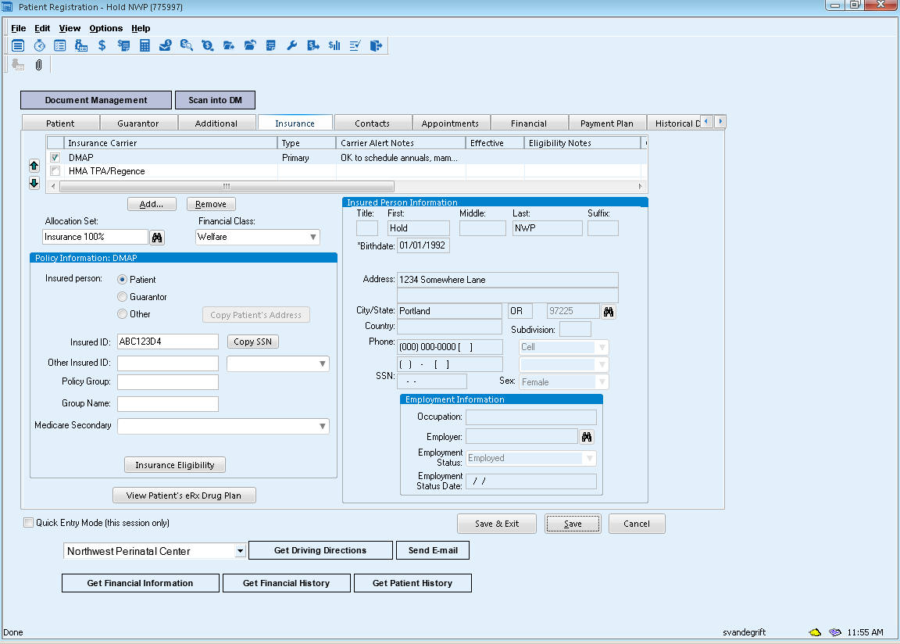

- Select Insurance Eligibility Button in the Policy Information box

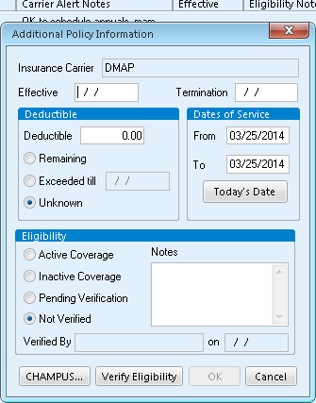
- Under the notes section in the Additional Policy Information Screen please add the following note so we know that Eligibility was checked at the time of the new patient scheduling.
Date OHP Verified// initials 3/25/14 OHP Verified//sv

Pediatric Urologist – Dr. David Lashley
Dr. David Lashley is our Pediatric Urologist and he comes to our office on Tuesday and Thursday afternoon. He has saved ultrasound appointment spots on NWP West Ultrasound 3 labeled Dr. Lashley and pink in color. Please schedule from the after lunch spot down.

These appointments for the most part should be reviewed by the Clinical Care Coordinator if they haven’t been seen by an MFM on the same day. The CCC will determine if a Consult or FYI is needed with the MFM following the Ultrasound and Consult with Dr. Lashley.

If the patient presents at Check out with a patient instructions it is ok to schedule without having the CCC Review as the patient has just been seen by an MFM.

How to let Dr. Lashley’s office know patient will need to see him.
- Send a Dr. Lashley cover sheet with patient information. This cover sheet can be found within the patients chart under the “Print/Letters/NWP-Lashley Referral.
- Patient registration sheet printed from registration
- Copy of the patient recent Ultrasound reports
- Fax all 3 pages to Dr. Lashley’s office fax number is on cover sheet
- You will need to complete a HIPAA Disclosure Log in the patients chart.
- File these 3 pages under the patient appointment date back in Phoenix area

Shelly confirms OB patients scheduled to see Dr. Lashley each week with Heidi Dr. Lashley M.A.

Pediatric Cardiologist –
A Pediatric Cardiologist comes to both of our offices during the month.
NWP West = 1st and 3rd Wednesday of each month
NWP East = 4th Monday of each month
There are saved ultrasound appointments spots on labeled Peds Cardiology and are “blue” in color. Please schedule from the LUNCH down as much as possible or first available time slot you need
Appointment lengths = See Ultrasound Scheduling Guide
** Schedules have been built for the Pediatric Cardiologist in Centricity and we will schedule the patient time to meet with them outside of Ultrasound.
Patients who are referred to Pediatric Cardiology have usually already had an initial Fetal Echo with us and have seen the MFM. They are now referred to Pediatric Cardiology as they have seen some type of heart abnormality in the fetal heart.
How to let Pediatric Cardiology office know a patient will need to seen
- Send a cover sheet with patient information. This cover sheet can be found within the patients chart under the “Print/Letters/NWP-Pediatric Cardiology.
- Patient Registration sheet printed from registration
- Copy of the patient’s recent ultrasound report
- Fax all 3 pages fax number is on cover sheet
- You will need to complete a HIPAA Disclosure Log in the patients chart.
- File these 3 pages under the patient appointment date back in the Phoenix area

Shelly confirms with Peds Cardiology office that our schedules match one week before the appointment and two days prior.

- If you have an urgent appointment that needs to either see Dr. Lashley or Peds Cardiology and the schedules are full please see Shelly for assistance. Phone calls to Dr. Lashley or Peds Cardiology offices will need to be made before adding another patient to the schedule.

Example of how to complete a HIPAA Disclosure Log

- From the patients chart, select a “New Document”
- Select Encounter Type “HIPAA Disclosure Log”
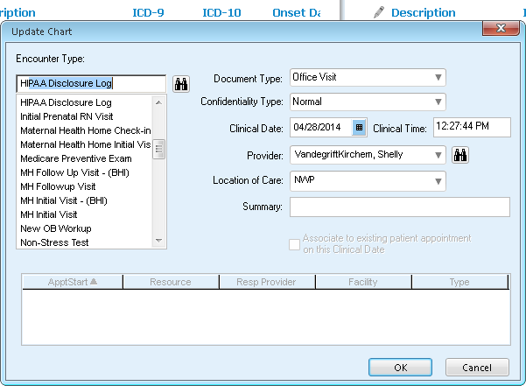

- “OK”
- Select the tab labeled “Intentional”
- Fill in the fields, see example below

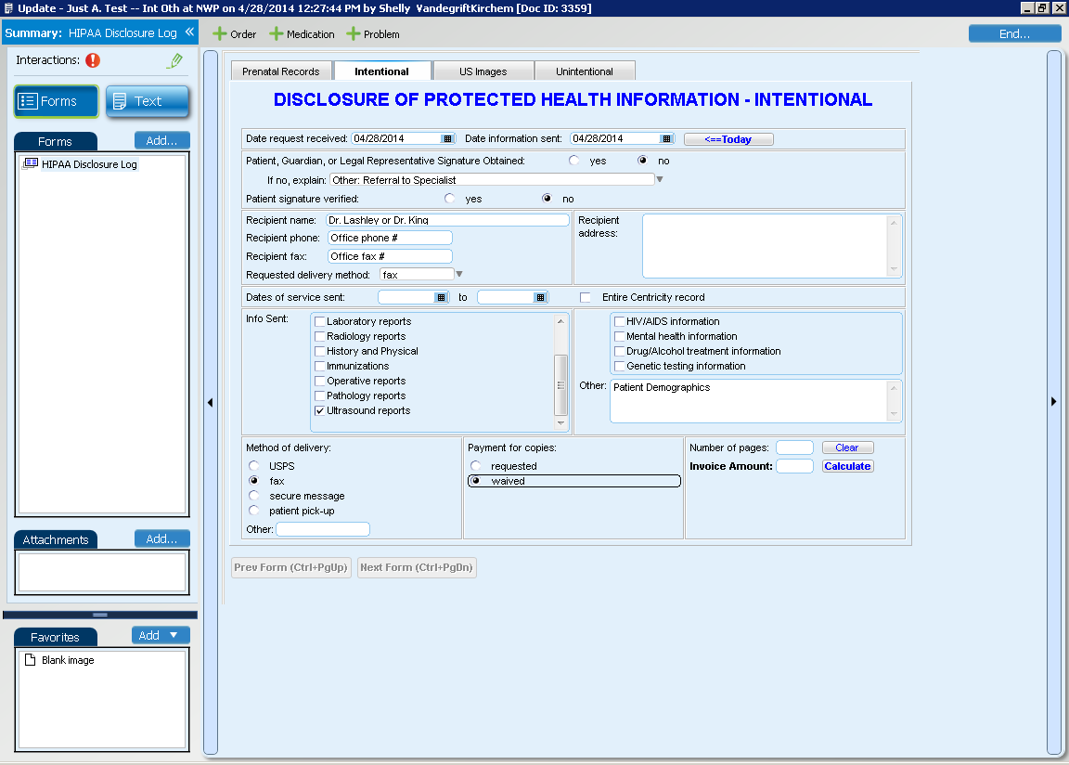
Put the date of the Ultrasound or a range of dates if sending more than one report.

- Select “End”
- Fill in “Summary line” See Example below
- Sign document. No need to route to anyone.
- Done! File information faxed under appointment date in the Phoenix scheduling area.
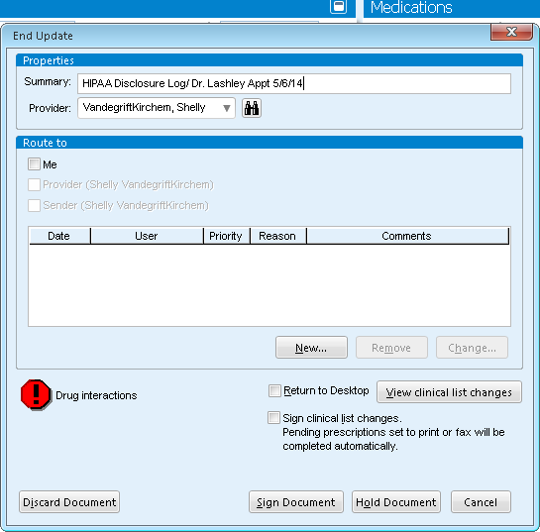

Dating/Viability and SEQ Screening orders

Check Out:
When putting in referrals, it would be best if patient’s have 2 orders (one for D/V and one for SEQ Screening) to put the SEQ1 Screening Phoenix summary line as “schedule after D/V US”. It will be the scheduler’s job to change the summary line after the D/V US is scheduled.

Schedulers:
If you see that a patient has two orders in her chart, one for dating/viability and one for SEQ Screening, please inform the patient at the time of scheduling her D/V US that her provider has sent two separate orders. You can then tell the patient that the SEQ1 Screening would be scheduled after her D/V US unless she is in the time frame for the SEQ Screening, then the ultrasounds could be scheduled together. Please ask the patient to stop by check out after her D/V US to schedule her SEQ1 Screening (unless she says she is no longer interested in the screening). After you schedule the patient’s D/V US, please put a pop up in the patient’s registration that says: “Please have patient stop by check out after D/V US on ____ to schedule SEQ1 Screening (Non AMA or AMA) see open Phoenix.” This would queue the front desk to inform the patient at check in for their D/V US that she has a separate order from her doctor to schedule another appointment at our office.

Check In:
When a patient checks in for her dating/viability US please check her patient alert notes to see if there is an order for a SEQ Screening. If so, to preface this conversation, you could say: “It looks like your provider has sent another order to have you schedule a SEQ1 Screening at our office. If you would like to schedule this appointment today, please stop by our check out desk to schedule after your ultrasound.” If the patient has questions about what the screening is you can tell her that the SEQ Screening is a genetic screening offered to every pregnant woman during pregnancy. If the patient wants further information, please refer her to call her doctor’s office.

Check Out:
After the patient has her D/V US, the sonographers will put an update in the patient’s chart if her EDD has changed. This will be found in the chart and it will say “updated EDD”. Please look at this when scheduling the patient for her SEQ1 Screening. If there is not an update in the patient’s chart, then the patient’s EDD has not changed and you can use her EDD listed in her chart banner.

Please also note, if the patient states that she is declining SEQ Screening or genetic testing, this will need to be notated in the Phoenix and the referring provider’s office will need to be notified. The order can then be closed.

NWP Appointment Notes Standards:
- Put sequence of appointments using schedule/provider initials and time
- What is being ordered
- Reason it is being ordered
- Any other info ( Interpreter, extra notes)
- Referring provider
- //initials

Examples:
US(850) Dating/Viability t/f w/Dion @ 930), scheduled w/Shayla/PKN//sv

US(850) Dating/Viability, unsure LMP, Hx of SAB E. Reindl//sv

US (850) Lab(930) SEQ 1 – Non AMA, L. Thum//sv

US(850) RN(930) TL(945) Anatomy Survey, MFM Consult – Hx of Preterm Delivery E. Reindl //sv

WB(800) Genetic Consult – AMA E. Reindl//sv

Behaviorist Scheduling
Initial Behavioral Health appointment (60min)
- It is perfectly okay—in fact, it is hoped for—that when a PK (PKS, PKN, NWP, NWG) patient calls or comes to the desk trying to schedule an INITIAL behavioral health appointment (the 60 min one) that they be scheduled with either, whomever has the soonest or best opening.

Fup Behavioral Health appointments (30min)
- When a patient is scheduling a FOLLOW UP appointment (the 30 min one), they need to be scheduled with the behaviorist whom they saw prior, since there is quite a bit of continuity between visits that would be difficult to maintain with a new person. The exceptions to this may be a crisis and the behaviorist they have been seeing is unavailable or a new episode of care. You may want to ask us if this situation arises so we can quickly look at the chart.

Cost of Behavioral Health Services (Handout given to Patients)
Behavioral health services are covered by many, but not all, insurance companies. At times, an insurance company may say that they cover behavioral health but still deny behavioral health claims. We understand how important it is for you to know the cost of your care prior to your visit. We’ve designed this structure to assure behavioral health services are affordable:
Type of Insurance | Cost of Behavioral Health Services
All Private/Commercial Insurance Plans | $40 per visit maximum charge to you if your insurance does not pay. This amount will be reduced to $32 per visit (a 20% discount) if you pay at the time of the visit. (If your insurance pays later, this amount will be credited to your account.)
Oregon Health Plan (primary insurance or secondary) | No charge to you.
. If you need more information before scheduling, please see one of our financial counselors.

Scheduling Behavioral Health Visits
Which appointment type do I use? | Additional Information
60 minute appointments  - Usually for initial visits  - Use 60 min spots or put 4 -15’s together(be sure to change appointment type to 60 min)  - Try for a max of 4 new patient appointments per day, 5 in a pinch. | - All patients newly referred to Behavioral Health appointment (this is their first visit) need a 60 minute visit.  - Patients referred for a new problem or haven’t been seen in 4-6 months (if in doubt but you don’t see a prior visit in documents, schedule for 60).  - There are also some high acuity patients who are just regularly on 60 min spots.
30 minute appointments  - Usually for follow up appointments  - Use 2 -15 minute slots (be sure to change appointment type to 30 mins) | - 30 min is typical length of appointment for a follow up (has already been seen x1 in recent past).  - If you are not sure what to do, check documentation from most recent BH visit.
15 or 45 (or other) appointments  - Rarely used | - Only use this length of time if specifically ordered by behaviorist or you are rescheduling someone who was already on this length of visit.  - This is going to be less than 1% of patients.
If Katie does not have an appropriate opening for an initial appointment in the next 1-2 weeks check other schedules for openings.  - Katie’s PKS Extended hours on Tuesdays from 5-7:30 pm  - Julie Lucisano at PKS for initials | - Katie offers appointments 5-7:30 pm at PKS. You will find the schedule on the Tuesday PKS Extended Hours schedule. Be sure to tell patient that the appointment will be at PKS (9550 SW Barnes, may have to call at door to be let in)  - Julie Lucisano, behaviorist at PKS. Her schedule is on PKS Ancillary template (will be moving to PKS Clinicians template soon). You would not schedule someone who saw Katie for an initial with Julie for follow up unless instructed otherwise.

For discussing provider orders:
“When you were in the clinic recently (or x date) to see (x provider) your provider referred you to our behavioral health department. I am calling to follow up on that referral and to offer to schedule that appointment for you.”
Offer their home clinic location first but may also schedule at other locations, especially if Peterkort patient they can see Julie or Katie.
With questions about why they were referred:
There will be a problem listed on the order—sometimes the problems are easy to discuss or communicate about (insomnia, obesity, diabetes, and hypertension) but some may be more general or hard to know how to discuss such as “maternal mental disorder” which usually means depression or anxiety in pregnancy. I recommend staying away from the specific reason for referral as much as possible and discussing the service in more general terms such as—
“A behaviorist is a therapist who works right in the WHA clinics. Behavioral health is a short-term, action-oriented approach to supporting your health and well-being.
If you decide to schedule an appointment, at your first visit you will discuss what has been going on for you, what you have tried so far to make things better and what has and has not worked. At the end of your visit, we you will come up with a specific plan for moving forward to address the issue. This plan may include things you can do at home to manage your condition/situation, more behavioral health appointments, a referral to another provider or something else that you come up with together, depending on your needs.
Behaviorists normally see patients somewhere between 1 and 6 times. The first appointment will take 40-60 minutes and any follow-ups would be 20-30 minute appointments. If you are looking for a longer term therapist or psychiatrist, the behaviorist can help you connect with this as well.”
Behavioral Health Scripting:
Copay/insurance questions:
Basics:
OHP: NEVER any cost to patient, even if OHP is secondary, tertiary etc.
Commercial plans: As low as office visit copay for a medical visit but no higher than $40 if billed or $32 if paid at time of visit.

“Behavioral health is billed on the medical side rather than the mental health side and is a relatively new approach to patient care. So, we don’t always have a clear answer as to whether or not insurance companies will pay, even if they have been credentialed by a specific company. In light of this, WHA has adopted a low-cost model for behavioral health. This means that we will bill your insurance company for the appointment but, if they don’t pay us we don’t pass the full cost on to you, we cap your responsibility at $40 per visit. You may choose to pay at the time of visit and, if you do so, would receive a 20% discount ($32). If you ever receive a bill from WHA for more than $40 for a behavioral health visit just call our business office at 503-601-3623 and the bill will be adjusted for you.”

If there are additional questions after you share this information, refer patients to a financial counselor or their insurance company. Do not try to help them figure out specifics about their insurance plan!

HIPAA Scripting
Discussing Patients with Individuals Who Are Not Listed on the Patient’s “Permission to Communicate” Form

WHA: Thank you for calling Women’s Healthcare Associates. This is (your name). How can I help you?

Caller: My girlfriend asked me to reschedule her appointment for next week. She’s stuck in a meeting today and can’t call in

WHA: What’s your girlfriend’s name and date of birth?

Caller: Sally Smith, 01/01/1983

WHA: What’s your name?

Caller: John

WHA: Can I have your last name please?

Caller: Doe

WHA: Just a moment please

WHA: I’m so sorry; I don’t see that we have a patient with that name who has authorized us to discuss any information with you

Caller: She just asked me to reschedule her appointment; she’s at work all day

WHA: I apologize, but because of changes to the federal HIPAA laws and our commitment to protect patient privacy, I’m not able to discuss this patient’s appointments with you right now. We require our patients to call us themselves.

Caller: This is absurd. I have been in with her for all of her appointments, and she asked me to do this!

WHA: Again, I am so sorry for the inconvenience, but I don’t see that we have a patient with the name you gave me who has authorized us to discuss any account with you.

For urgent medical issues, if a patient is unable to call in herself because of a medical emergency, it is always ok for nursing staff to TAKE information from whoever is calling in and give directions based on the symptoms they are describing. Specific medical information from the patient’s chart should not be shared with unauthorized individuals. If the patient is available in the room, she can give verbal permission for WHA to discuss her specific details with the caller; this should be documented in the phone note.

Add Patient Alert note to patient’s account asking front office to ask patient to review “Permission to Communicate” form at next appointment.

If caller is still frustrated after conversation or thinks they should have been authorized by the patient, send a flag or an e-mail to Amber or PSS so that we can look into the patient’s appointment history, figure out what happened, and provide feedback to the front desk team.

28wk Lab (GTT) or Early GTT Workflow
Scheduling:
- Put patient on the phlebotomy schedule too at the end of the appointment
- Put in the appointment notes that the patient will be doing the 28wk lab (GTT) or if I will be an Early GTT
- Reinforce instructions on the bottle to alert check in on the day of the appointment what time they started the Glucose drink

Check in: (Day of appointment)
- Patient arrives for visit
- Check in sees patient is scheduled on the lab schedule, reviews what lab is for; if 28wk lab ask patient if Glucose drink was consumed
- Ask the time she started the drink (blood will be drawn 1hr after drink was started)
- Inform patient to let any staff member know her lab is due giving us a 10min warning
- Check in patient for appointment
- Add the time the glucose drink was started in the appointment notes
- Call back over the walkie inform Navigator patient is ready and what time lab will need to be drawn, the navigator will reach out to the Lab/phlebotomy if assistance is needed with the draw.

Navigator:
- Review daily schedule for 28wk lab or early GTT’s scheduled

Lab/Phlebotomy:
- Can review daily scheduled 28wk lab or early GTT’s scheduled on the site Lab/Phleb schedule

PMHNP Scheduling –
Kristen Venderbush – PKN Schedule
DAY OFF:
Kristen’s normal day off is FRIDAY, and she is usually in the office Monday through Thursday. She does have some reoccurring meetings that you will notice (most frequently on Tuesdays) which take away some of her clinic time.
IS SHE TAKING NEW PATIENTS?
Yes BUT she can ONLY see patients who have been referred to her by a WHA Clinician.
**If an established WHA patient would like to see her but has not been referred, you are welcome to send a phone note to their clinician’s pod requesting a referral. Once orders have been entered, we can call her to schedule. **
WHAT DO I DO IF A NON-WHA PATIENT CALLS IN REQUESTING TO SEE HER?
Since Kristen is an “internal resource,” she cannot see patients who have not been referred by a WHA clinician. Upon hearing this, there are some new patients who will ask to schedule an appointment with a WHA clinician in order to be referred. This is really not ideal, because getting them in for an annual or a problem visit does not guarantee that the WHA clinician will agree to refer them to Kristen. It is a good idea to point these external patients in the direction of other resources.
If a non-established patient or an outside office calls to inquire about scheduling with her, here is what I would recommend for scripting:
“Unfortunately, Kristen is an internal resource for patients referred by a WHA clinician so we are unable to schedule you. That being said, we would be happy to give you the numbers for some alternative clinics that may be able to assist you (see below).”
If a patient requests to schedule with a WHA provider in order to be referred to Kristen:
“If you are truly due for an annual or have a GYN problem I would be happy to schedule you, however I want to communicate that seeing a WHA clinician is not a guarantee that they would agree it is appropriate to refer you to Kristen. If you are not actually due for an appointment, then we would recommend reaching out to either Wildwood or Western (see below).”

These two offices are where we most commonly refer patients for MH Services outside our clinic:

Wildwood Psychiatric Resource Center
16110 SW Regatta Lane
Beaverton OR, 97006
Phone: (503) 629-2131

Western Psychological & Counseling Services
(Multiple Locations see website)
Phone: (503) 624-2600

APPOINTMENT TYPES:
NP Office Visit 90 – This type is used when a patient is seeing Kristen for the 1st time (again, they are established WHA patients, we are just using this specific allocation to clearly indicate that this is the first time she is seeing this pt). She has openings for two new patients every day at 9:00am and 1:30pm.
TO DO: Please flag Gini Bergin (FC) after scheduling this initial appointment so she can investigate benefits!

**At the conclusion of a visit, Kristen will recommend that the pt have either a 60 min or 30 min follow up, which are scheduled using the following appointment types**

Est Office Visit 60 – This type is used for a follow up (typically when Kristen is doing both therapy and medication management).
Est Office Visit 30 – This type is used for a follow up (typically when Kristen is just doing medication management).

SCHEDULE LAYOUT:
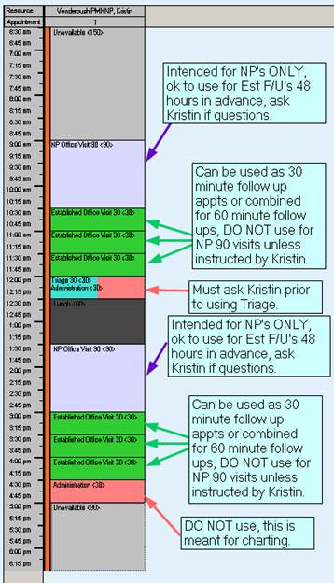

WHAT DO I DO IF I CAN’T FIND A SPOT?
If you are having difficulty finding a spot, I would recommend reaching out to one of the following:
- Hannah Wilson (me) PSS – x3748
- Dana Krebs PSR – x3534
- Miranda Marshall PSR – x3787
- Kristin Venderbush – x3532
If we don’t answer?
- Flag the PKN Patient Services Proxy and we would be happy to give the pt a call back!

IF A PATIENT IS CALLING IN REQUESTING TO SCHEDULE OR R/S HER FOLLOW UP, HOW DO I KNOW WHAT SHE NEEDS?
Unfortunately, visits with Kristin are hidden in the chart, which means that we can’t look at patient instructions for scheduling. At PKN, when a patient is leaving her appt, Kristen sends her out with a handwritten note stating the length of follow up needed and when.

Scenario 1: A patient is calling to reschedule her appointment. You are then just going to duplicate what was already scheduled in the next available timeslot.

Scenario 2: A patient left her appt with scheduling and is now calling to schedule her follow up. Ask the pt if she still has Kristin’s handwritten instructions from her last visit. If not, you can ask whether or not she needed a 60 or 30 minute follow up and schedule accordingly. Worst case scenario, if she doesn’t remember at all, you can flag the PKN Patient Services Proxy and Dana or Miranda can consult with Kristen and give the pt a call back.

PMHNP No Show Workflow

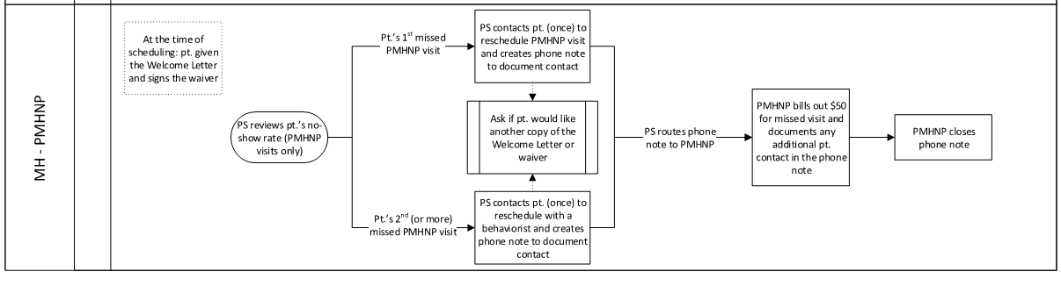

Apply too:
No Shows
Patients who do not call more than 24 hours in advance to reschedule or cancel (Fail).
Reasons to not charge no show fees:
Inclement weather
Wrong location (which may not apply for us)
Hospitalization
Illness
Death in family
Car accident
FAQ’s –
- At NWP, we seem to schedule new visit for PMHNP’s by phone with the patient, instead of in person. Would we mail then the Welcome Letter?
  - Yes, when scheduling by phone, we should mail the welcome letter and document in the appointment notes, “welcome letter given/mailed.” You do not need to put in a pop up regarding the waiver; the trigger for PKN to give the waiver is the apt type (NP OV 90) so that makes it easy. The PMHNP No Show Policy and Waiver will be printed at the time of patient check in at PKN.
  - If you schedule in person you will need to print the Welcome Letter and the PNHNP No Show Policy located in Centricity Handouts to have the patient sign

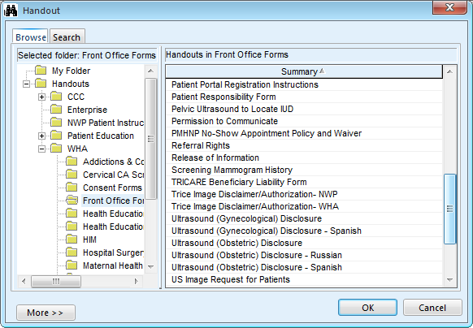

- I found the PMHNP No show Policy and Waiver in the Centricity Handouts, but where do we find the Welcome Letter to print out?
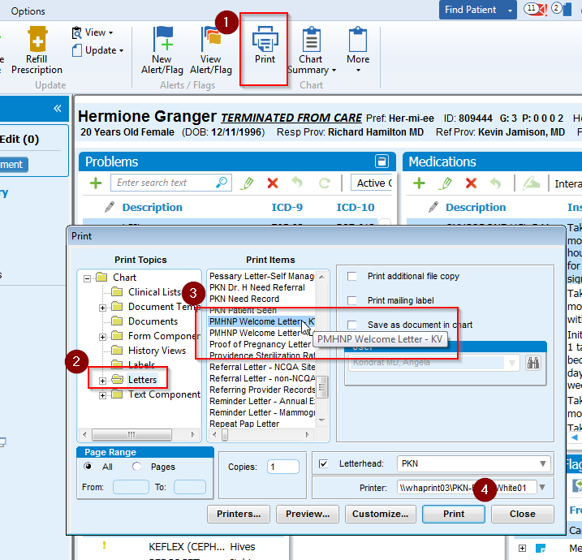
  - The welcome letter is printed from the chart, here is a screenshot:

- Will we be charging OHP patient the no show fee? Would we need them to sign the OHP
Responsibility waiver?
  - We will still have the patient sign the PMHNP waiver for continuity but they will not be charged per our agreement with OHP.

Surrogate Pregnancy Scheduling

Is this a surrogate pregnancy?

If the answer is Yes, follow these steps:
- Schedule the NWP appointment
  - Same day scheduling please review with Financial Counselor prior to scheduling.
- Flag a Financial Counselor
- Let the patient know that the Financial Counselor will check the patient’s insurance coverage
- If we cannot verify coverage, we will only see the patient on a self-pay basis, this will require a $500 deposit to start
- Our goal is ‘no surprises’ financially to the patient

Postpartum Scheduling –
- Routine 3 week postpartum visits:
Schedule between 21-56 days after Delivery.
Delivery day = Day 0 and count out days after that

  - Scheduled with either the primary responsible provider (assuming this is correct in the banner – double check) or the delivering provider.
  - Not to be scheduled with anyone else who really doesn’t know the patient (this applies to reschedules). In other words, if a patient no shows her 3 week postpartum visit and attempts to reschedule… she should only again be rescheduled with the responsible provider or delivering provider.
- BP checks and hospital follow-up
  - Follow-up arranged for non-routine postpartum visits such as BP checks, early incision checks, diabetes follow-up, etc., can be scheduled with any of the MFMs as these tend to be more time dependent. However, the effort should be again made to have these patients first seen by either the primary provider, delivering provider first, or the discharging provider.

